ROUND 1

Which movies/TV shows do these clips come from?

1. Austin Powers

2. Harry Potter

3. Titanic

4. Liar Liar

5. Shrek

6. The Incredibles

7. Inception

8. Jurasic Park

9. Batman

10. Love Actually

ROUND 2

Where in the world – country outlines

1. 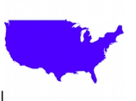

2. 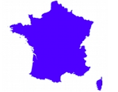

3. 

4. 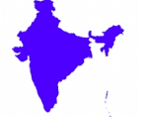

5. 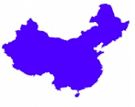

6. 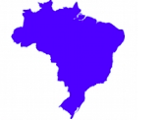

7. 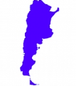

8. 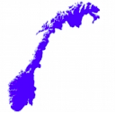

9. 

10. 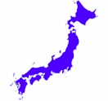

ROUND 3

Who is this?

|  |  |
| --- | --- |
| Macintosh HD:Users:andrewcottam:Desktop:Screen Shot 2020-04-29 at 20.26.54.png | Macintosh HD:Users:andrewcottam:Desktop:Screen Shot 2020-04-29 at 20.31.31.png |
| Macintosh HD:Users:andrewcottam:Desktop:Screen Shot 2020-04-29 at 20.28.01.png | Macintosh HD:Users:andrewcottam:Desktop:Screen Shot 2020-04-29 at 20.30.37.png |
| Macintosh HD:Users:andrewcottam:Desktop:Screen Shot 2020-04-29 at 20.28.41.png | Macintosh HD:Users:andrewcottam:Desktop:Screen Shot 2020-04-29 at 20.33.59.png |
| Macintosh HD:Users:andrewcottam:Desktop:Screen Shot 2020-04-29 at 20.29.39.png | Macintosh HD:Users:andrewcottam:Desktop:Screen Shot 2020-04-29 at 20.33.28.png |
| Macintosh HD:Users:andrewcottam:Desktop:Screen Shot 2020-04-29 at 20.32.13.png | Macintosh HD:Users:andrewcottam:Desktop:Screen Shot 2020-04-29 at 20.32.50.png |

ROUND 4

Yum yum – match them up

|  |  |
| --- | --- |
| Macintosh HD:Users:andrewcottam:Desktop:Screen Shot 2020-04-29 at 20.38.33.png | ‘India |
| Macintosh HD:Users:andrewcottam:Desktop:Screen Shot 2020-04-29 at 20.38.50.png | Sweden |
| Macintosh HD:Users:andrewcottam:Desktop:Screen Shot 2020-04-29 at 20.39.58.png | Italy |
| Macintosh HD:Users:andrewcottam:Desktop:Screen Shot 2020-04-29 at 20.40.40.png | UK |
| Macintosh HD:Users:andrewcottam:Desktop:Screen Shot 2020-04-29 at 20.38.18.png | USA |
| Macintosh HD:Users:andrewcottam:Desktop:Screen Shot 2020-04-29 at 20.41.28.png | Australia |
| Macintosh HD:Users:andrewcottam:Desktop:Screen Shot 2020-04-29 at 20.41.12.png | Japan |
| Macintosh HD:Users:andrewcottam:Desktop:Screen Shot 2020-04-29 at 20.38.01.png | Turkey |
| Macintosh HD:Users:andrewcottam:Desktop:Screen Shot 2020-04-29 at 20.44.06.png | Korea |
| Macintosh HD:Users:andrewcottam:Desktop:Screen Shot 2020-04-29 at 20.37.42.png | Spain |

ROUND 5

Where am I from?

|  |  |
| --- | --- |
| Macintosh HD:Users:andrewcottam:Desktop:Screen Shot 2020-04-29 at 20.51.35.png | Indonesia |
| Macintosh HD:Users:andrewcottam:Desktop:Screen Shot 2020-04-29 at 20.49.59.png | Kenya |
| Macintosh HD:Users:andrewcottam:Desktop:Screen Shot 2020-04-29 at 20.50.12.png | New Zealand |
| Macintosh HD:Users:andrewcottam:Desktop:Screen Shot 2020-04-29 at 20.50.41.png | India |
| Macintosh HD:Users:andrewcottam:Desktop:Screen Shot 2020-04-29 at 20.50.58.png | Malaysia |
| Macintosh HD:Users:andrewcottam:Desktop:Screen Shot 2020-04-29 at 20.51.12.png | China |
| Macintosh HD:Users:andrewcottam:Desktop:Screen Shot 2020-04-29 at 20.51.57.png | Canada |
| Macintosh HD:Users:andrewcottam:Desktop:Screen Shot 2020-04-29 at 20.52.44.png | South Africa |
| Macintosh HD:Users:andrewcottam:Desktop:Screen Shot 2020-04-29 at 20.53.02.png | Australia |
| Macintosh HD:Users:andrewcottam:Desktop:Screen Shot 2020-04-29 at 20.54.38.png | Madagascar |